Go to www.turnitin.com

***IF YOU USED TURNITIN.COM LAST YEAR, DO NOT MAKE A NEW ACCOUNT!

IF YOU ALREADY HAVE A TURNITIN.COM ACCOUNT:

STEP 1: LOG IN

- Click the “Log In” button in the top right corner.
- Enter your email address and password.
- Click “Log In”

STEP 2: ENROLL IN THE CLASS:

- Class ID: 16532954
- Enrollment key: adams

STEP 3: SUBMIT YOUR ASSIGNMENT:

- Click on the class name – “English 2”
- Find the assignment name
- Click the blue “Submit” button to the right of the assignment title
- Make sure the blue text at the top of the page says “Single File Upload”
- In the “Submission Title” box, type the title of the assignment
- Click “Choose from Google Drive”
- Enter your student email and password, then click the blue button to allow access to your Google Drive
- Find your file in Google Drive, then click “Select”
- Click “Upload”
- Check the preview to confirm that you are uploading the correct document.
- Click “Confirm”
- Wait for the screen that says, “Congratulations - your submission is complete!”
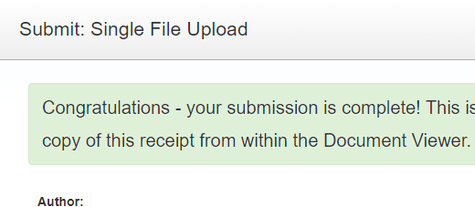

IF YOU DO NOT ALREADY HAVE A TURNITIN.COM ACCOUNT:

- Click “Create Account” in the top right corner
- Click the link that says “Student”
- Enter the Class ID: 16532954
- Enter the Enrollment key: adams
- Enter your name and email address – use the email address that you check regularly
- Create a password – make sure it is something you will remember!
- Select a secret question – make sure it is something you will remember!
- Click the button that says “I Agree – Create Profile”

Once you have created your account and logged in, continue to STEP 3 above.

